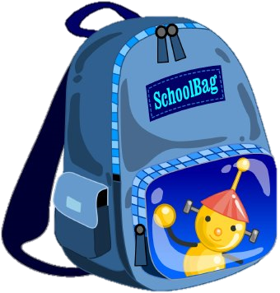
Amount Item Notes
7th Grade
SCHOOL SUPPLY LIST
Taipei Adventist American School

1 | each | 3 ringed binder and lined paper for each
2 |  | Notebooks with grid paper | For math class
 |  | Blank sketchbook for art class
5 |  | Notebooks | 3 specifically for Ms. Maletin’s classes
3 |  | #2 pencils or mechanical
3 |  | Erasers
1 | Pack | Colored Pencils
1 | Box | Crayons
3 |  | Red & black pens
3 |  | Highlighters
1 | Pack | Markers
3 |  | Liquid glue
1 |  | Pack of Face-masks (10 count)
1 |  | Tape
1 |  | Scissors
1 |  | Ruler
3 |  | Post-it note pads
1 |  | Post-it note pad | For all Social Studies classes
2 |  | Pads of index cards
2 |  | Notebook
1 | Set | Lined paper
1 |  | Dry Erase Marker
 |  | Additional supplies may be needed at a later date for Science Fair & other projects**

